- INTRODUCTION

Adders are the most fundamental part a microprocessor and many digital signal processing chips. Adders are essential not only for addition, but also for subtraction, multiplication, and division. Addition is one of the basic arithmatic operation. A fast and accurate operation of a digital system is greatly influenced by the performance of the resident adders.

- 1. Brief History
Addition, subtraction, multiplication and division. All these operations are most fundamental part of the today's computational world. Man kind has evolved from counting to computers through series of changes. Not just in the present, if we go way back thousands of years, we find some sort of method used to accomplish the required calculations. Initially hand was the tool used to calculate, which then evolved into tallies made by carving notches in wood, bone, and stone. Well obviously the way humans evolved, so as their need for processing huge data which gave birth tmany algorithms to perform required task with many calculation tools. Let us see some of the tools that were used which lead to the development of present day computing.

The abacus, probably invented in Sumer between 2700 and 2300 BC, is an early computing device invented by humans. Whilst it has no automatically moving parts or gears the movement of its beads on its structured rods provides a powerful mechanism for carrying out all four arithmetic operations. As late as the middle of the last century the speed of these on the abacus could rival or exceed the speed of the same computations performed on the latest electric calculating machines. Over centuries, support for arithmetic was provided either by the abacus, or other counting technologies (such as the counting board and calculi and "the pen and jeton"). In 1617 John Napier built on a known method of "lattice multiplication" to publish his "rods" or Napier's Bones which, appearing in a range of forms over subsequent centuries, were found to considerably facilitate the performance of multiplication and division, especially by those not well equipped with memorised multiplication tables.
After the era of manually operated devices came the era of mechanical devices.

1.1.Pascal's calculator
Blaise Pascal along with Wilhelm Schickard was one of two inventors of the mechanical calculator in the early 17th Century. Pascal made his invention in 1642. He was spurred to it when participating in the burden of arithmetical labor involved in his father's official work as supervisor of taxes at Rouen. First called the Arithmetic Machine, Pascal's Calculator and later Pascaline, his invention was primarily intended as an adding machine which could add and subtract two numbers directly, but its description could, with a bit of a stretch, be extended to a "mechanical calculator, in that at least in principle it was possible, admittedly rather laboriously, to multiply and divide by repetition.
Pascal designed the first mechanical calculator to still survive from the 17th century. His device was particularly successful in the smooth working of the so-called "carry mechanism" - the mechanism which allows an addition of 1 to 9 on one dial to replace the 9 with a 0, and carry 1 to the next dial. His innovation made each digit independent of the state of the others allowing for multiple carries to rapidly cascade from one digit to another regardless of the capacity of the machine.

1.2.The Engines
Charles Babbage (1791-1871), computer pioneer, designed two classes of engine, Difference Engines, and Analytical Engines. Difference engines are so called because of the mathematical principle on which they are based, namely, the method of finite differences. The beauty of the method is that it uses only arithmetical addition and removes the need for multiplication and division which are more difficult to implement mechanically.
Difference engines are strictly calculators. They crunch numbers the only way they know how by repeated addition according to the method of finite differences. They cannot be used for general arithmetical calculation. The Analytical Engine is much more than a calculator and marks the progression from the mechanized arithmetic of calculation to fully-fledged general-purpose computation. There were at least three designs at different stages of the evolution of his ideas. So it is strictly correct to refer to the Analytical Engines in the plural.
Well all of what we have today ie the computers and many more computational devices evolved from what we have seen above to tackle the problem of computation, which is basically additions in the lowest level.

- PROBLEM STATEMENT

“Addition of two large numbers”- We know how to add two integers using a perfectly simple and useful algorithm learned from school or even earlier. This is perhaps one of the very first techniques we learn in mathematics.

What about big integers?
Since we know how to add “small” integers, its not so hard to apply the same algorithm on big integers. The only problem is that the addition will be slower and sometimes (done by humans) can be error prone.
So practically the algorithm is the same, but we can’t just put a 1 million integer into a standard computer type INT, right? That means, the question here is how we represent/store/execute such “big integers” in our application. A common solution is to store the “big integer” into an array, but in this problem we store the “big integer” in a “CIRCULAR LINKED LIST” which makes the traversing much more easier and helps us to implement the serial ripple carry adder.

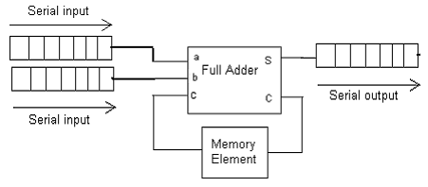

The Block Diagram Of A Serial Adder

- INPUT

Two large positive numbers.
Example.1:
    - 1234567890123
    - 1234567890237
Example.2:
- 1872639812537659712537612386547826394512753
- 1087263815237965213976421397148972153523795
Example.3.
- 18726398125376597125376123865478263945127536750869857579
- 1087263815237965213976421397148972153523795060876876795

  - OUTPUT

Sum of two large positive numbers.
Sum for Example.1. = 2469137580360
Sum for Example.2. = 2959903627775624926514033783696798548036548
Sum for Example.3. = 19813661940614562339352545262627236098651331811746734374

- ALGORITHM

Even though we based our project on making a serial adder using linked list, we tried to tackle the problem using a fast adder too so that, we would get a better picture in comparing the working of these two models.

5.1.ALGORITHM1

Algorithm serialAdder(a[1,2,..,n], b[1,2,...m])
//Algorithm to compute the sum of two large positive numbers
//INPUT: two large positive numbers of size n and m, stored in the form of a linked list.
//OUTPUT: sum of numbers stored in the linked list.

carry = 0
for i = 1 to min(n , m) do //till we reach end of a number
s[i] = (a[i]+b[i]+carry) % 10
carry = (a[i]+b[i]+carry) /10
if(n<m) then // a has lesser number of digits
for i = n to m do
s[i] = (b[i]+carry) % 10
carry = (b[i]+carry) / 10
otherwise //b has lesser number of digits
for i = m to n do
s[i] = (a[i]+carry) % 10
carry = (a[i]+carry) / 10

Here a[i], b[i], s[i] are the ith elements of the linked list.

5.2.ALGORITHM2
Algorithm fastAdder(a[1,2,..,n], b[1,2,...m])
//Algorithm to compute the sum of two large positive numbers
//INPUT: two large positive numbers of size n and m, stored in the form of an array.
//OUTPUT: sum of numbers stored in the array.

Calculate all Gi's and Pi's parallely where,
G[i] = (a[i] + b[i])/10
P[i] = (a[i] + b[i])%10
Calculate all Ci's parallely using the carry look ahead algorithms
C[i] = clal(i,G,P)
Calculate all Si's parallely where,
S[i] = (P[i] + C[i])%10

Algorithm clal ( i,G,P)
//Algorithm computes the carry produced for ith place
if(i==0)
return 0;
if(G[i-1] == 1)
return 1;
else if(P[i-1]==9)
return clal(i-1,g,p);
else
return 0;

Serial Adder Algorithm (pictorial)

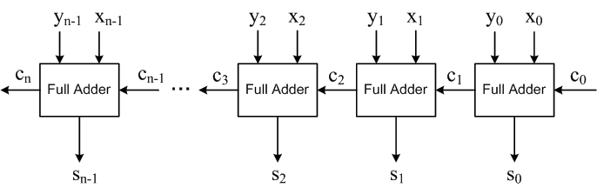
Carry Look Ahead Adder Algorithm(pictorial)
